
D O K U Z E Y L Ü L U N I V E R S I T Y
FACULTY OF ENGINEERING

COMPUTER ENGINEERING DEPARTMENT

Project Final Report

Course : CME1102 - Project Based Learning -2
Project No : 1 Date: 01.04.2013
Project Name : Battleship

Prepared By : Group/Subgroup No:

Members: No: Name:
1. 2011510105 Berkay Türkgeldi
2. 2009510046 Ali Konya
3. 2011510039 Furkan Kaya

1. Project Description

In this project, we are asked to develop a two-player strategy game. The players have guess board and ship board. At the beginning of the game, each player place their ships on their own shipboards. Each player also have four ships and the sizes of the ships are different. After placing, players try to hit a target from opponent ship board and can see the result in the guess board.

2. Task Summary

2.1. Completed Tasks
Member | Task
Berkay Türkgeldi | Creating ship class, placing ships into the board,
Ali Konya | Creating board class, designing component of the screen,
Furkan Kaya | Creating player class, collecting

2.2. Uncompleted Tasks
Member | Task and Reason
Berkay Türkgeldi | There is no uncompleted task in the project.
Ali Konya | There is no uncompleted task in the project.
Furkan Kaya | There is no uncompleted task in the project.

2.3. Additional Improvements to the Project
Member | Additional Improvement
Berkay Türkgeldi | Adding artificial intelligence for the computer turn. Computer tries to make decisions logically
Ali Konya | Showing six round in the screen. When the screen has not space for writing, we create a space for good-looking
Furkan Kaya | We take coordinates from user one by one and every input we control the variable

3. Explanation of Algorithms

3.1. Screenshots
Explain the functionality of your solution by using key screenshots.
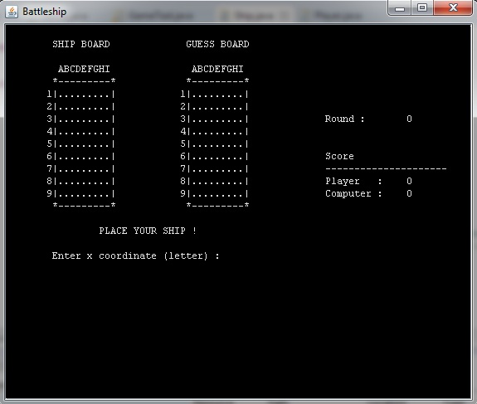

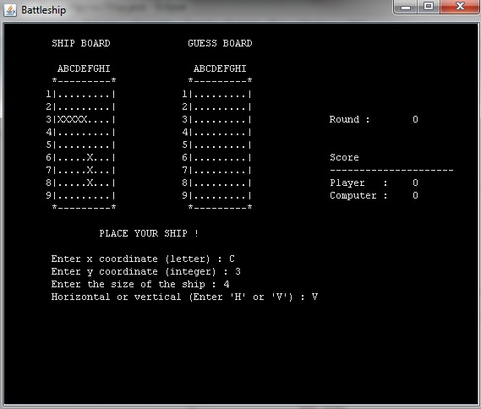

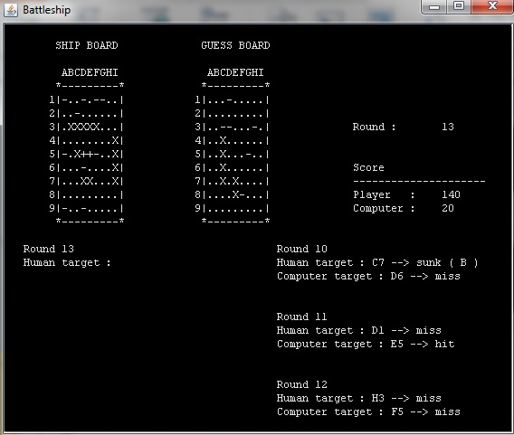

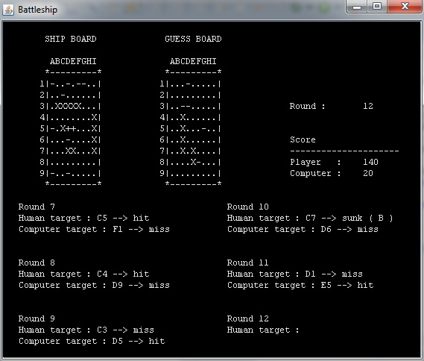

3.2. Functions

We used getter and setter methods for reach their values. The rest of the code has constructers and instances. Almost every possibilities consider in constructers

Additionally, we used available function to control ships are available for board. Board is used as parameter

3.3. Algorithms
Explain important algorithms and solution strategies in the project with code extracts. Use flowcharts if necessary.
Member | Algorithm/Solution strategy
Berkay Türkgeldi | When we control if the user’s ship is available for placing ship board, we use a strategy that we use start point and control its necessary neighbors and repeat until end point
Ali Konya | We use ship class and all ships have a board. At the same time we use player class and all player have two boards and four ships
Furkan Kaya | When user enter the x coordinate (letter), we think ASCII codes and we subtract 64 from original input for the array index

4. Problems Encountered
Member | Problems and Solutions
Berkay Türkgeldi | When a player hits a ship, we could not know which ship is hit by player, so we could not reduce its size to control sunk  We use another two dimentional array and when we take ships from user or computer, we assign ‘A’,’B’,’D’, or ‘P’ its index with respect to their sizes
Ali Konya | When computer hits, if next target will miss, it begins trying wrong places  We hold previous variable and activate it for conditions above
Furkan Kaya | When user place his/her own ships, it could place same ships in different places (same size)  We use a static array variable and control when user place a ship

5. Conclusions
Summarize your work, describe what you have learned from the project both technically and socially.
In this project, we have learned the basics of object oriented programing and we implement them. At the same time, we start to use different environment with eclipse and saw other technologies by the help of it.

6. References
www.w3schools.com

7. Appendices
7.1. Poster/Web page of the Project
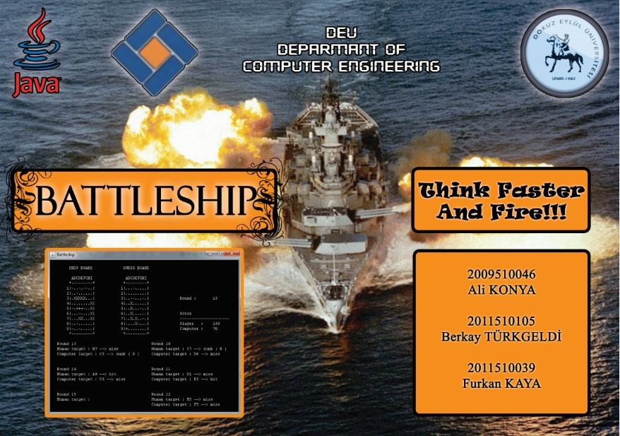
7.2. Code of the Project
Give clear, indented, fully commented code of your project.
